**DBMS LAB**

**Lab Assignment number 08**

**Name:** Aamir Ansari **Batch:** A **Roll no.** 01

**Aim:** Experiment to study and implement Join in SQL.

**Theory:**

Join:-

Join operation is used to retrive data from two or more than two tables based on some logical relationship between tables.

Join condition is specified on common column between two tables.

Join condition can be specified either from clause or where clause

There are two methods of specifying join condition

By using join key word

Without using join keyword.

Without using Join keyword:-

General syntax:-

Select <list of columns> from table1 as t1,table2 as t2 where t1.colname=t2.colname

Eg. Retrive empname and dname of dept for which emp is

working.

Select ename,dname from emp as e,dept as d where e.dno=d.dno

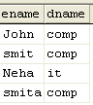

Select ename,dno,dname from emp as e,dept as d where e.dno=d.dno -- Error (Ambiguous column name dno)

Select ename,e.dno,dname from emp as e,dept as d where e.dno=d.dno

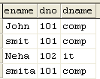

By using join key word:-

Select e.ename,e.dno,dname from( emp as e join dept as d on e.dno=d.dno)

**Types of Joins:-**

**1.Inner Join -**

Inner Join keyword returns rows when there is at least one match in both table.

An inner join requires each record in the two joined tables to have a matching record.

An inner join essentially combines the records from two tables (A and B) based on a given join-predicate.

The result of the join can be defined as the outcome of first taking the [Cartesian product](http://en.wikipedia.org/wiki/Cartesian_product) (or cross-join) of all records in the tables then return all records which satisfy the join predicate

Select e.ename,e.dno,dname from( emp as e inner join dept as d on e.dno=d.dno)

Two types:-1) Self join

2) Equijoin

**A. Self-join:-**

A self-join is joining a table to itself

Eg. Display empname ,supervisor name of supervisor

who supervises that employee.

Select e.ename as empname , s.ename as supervisorname from emp as e,emp as s where e.superssn=s.ssn

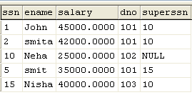 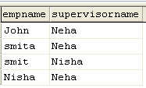

Employee Table Output

select *from emp as e,emp as s

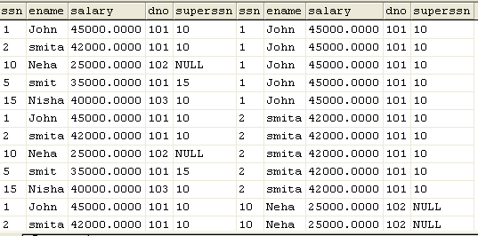

Eg. Display empname ,supervisor name of supervisor

who supervises that employee where supervisor salary is

greater than salary of supervisor.

Select e.ename , s.ename from emp as e,emp as s where

e.superssn=s.ssn and e.salary>s.salary

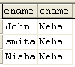

**B. Equi join:-**

Only rows satisfying selection criteria from both joined tables are selected. Selection criteria is based on equality condition on common column.

join condition uses only equality predicate "="

Eg. Display ename and dname of department for which employee is working.

select ename,dname from emp as e,dept as d where e.dno=d.dno

**2. Outer Join:-** Result of innerjoin + non matching records

LEFT OUTER JOIN - Rows satisfying selection criteria from both joined tables are selected as well as all remaining rows from left joined table are being kept along with null those are not having matching records in right joined table .

Select e.ename,e.dno,dname from( emp as e left outer join dept as d on e.dno=d.dno)

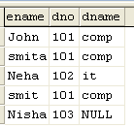

RIGHT OUTER JOIN - Rows satisfying selection criteria from both joined tables are selected as well as all remaining rows from right joined table are being kept along with Nulls those are not having matching records in left joined table values.

Select e.ename,e.dno,dname from( emp as e right outer join dept as d on e.dno=d.dno)

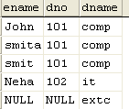

FULL OUTER JOIN - rows satisfying selection criteria from both joined tables are selected as well as all remaining rows both from left joined table and right joined table are those are not having matching records.

Select e.ename,e.dno,dname from( emp as e full outer join dept as d on e.dno=d.dno)

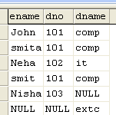

**Output:**

Display ename and dname of the department for which the employee is working using Joins.

1. Perform Left Outer Join

select Fname, Mname, Lname, Dname from (Employee as e left outer join Department as

d on e.Dno=d.Dnumber);

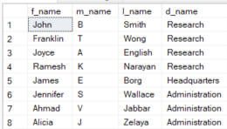

1. Perform Right Outer Join

select Fname, Mname, Lname, Dname from (Employee as e right outer join Department

as d on e.Dno=d.Dnumber);

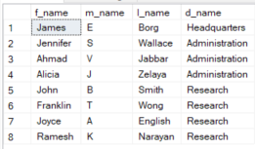

1. Perform Full Outer Join

select Fname, Mname, Lname, Dname from (Employee as e full outer join Department as

d on e.Dno=d.Dnumber);

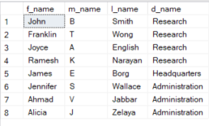.

**Conclusion:** Hence we successfully studied and implemented all types of Joins in DBMS.